INFOLABZ IT SERVICES PVT LTD

REACT | ASSIGNMENT 1 | 15 DAYS INTERNSHIP

**TASK 1 :**

**Webpage 1 :** Design a webpage with total 9 cards contains movie information as follow.

( apply card header , footer, image, body ) [Easy]

**Note :**

* Interns can use react bootstrap or normal bootstrap
* Search on bootstrap cards / react bootstrap cards
* Try to create a webpage as shown below.

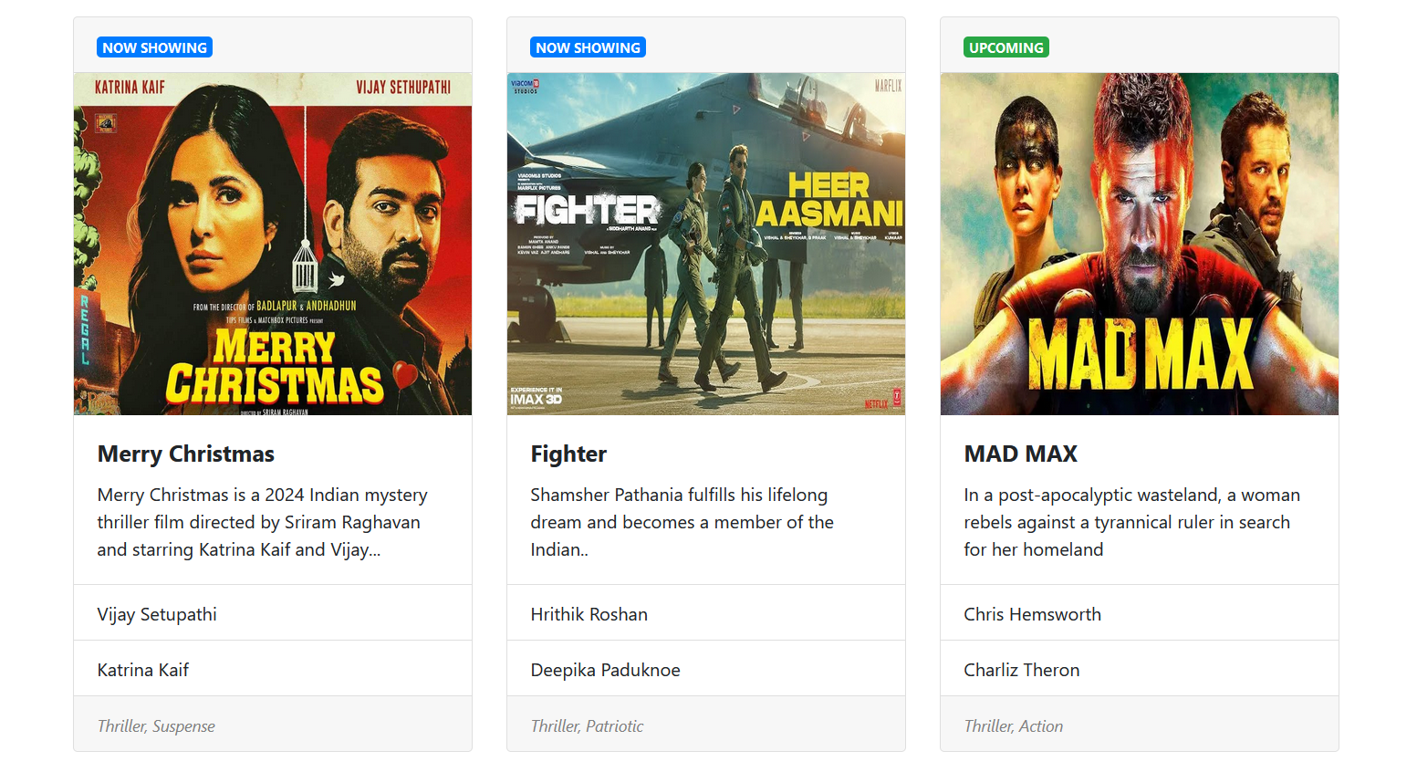

( Above web page contains 3 rows , each containing 3 cards. Total 9 movies information )

**TASK 2 : PASSING API DATA TO BOOTSTRAP TABLE**

API : <https://inshortsapi.vercel.app/news?category=sports>

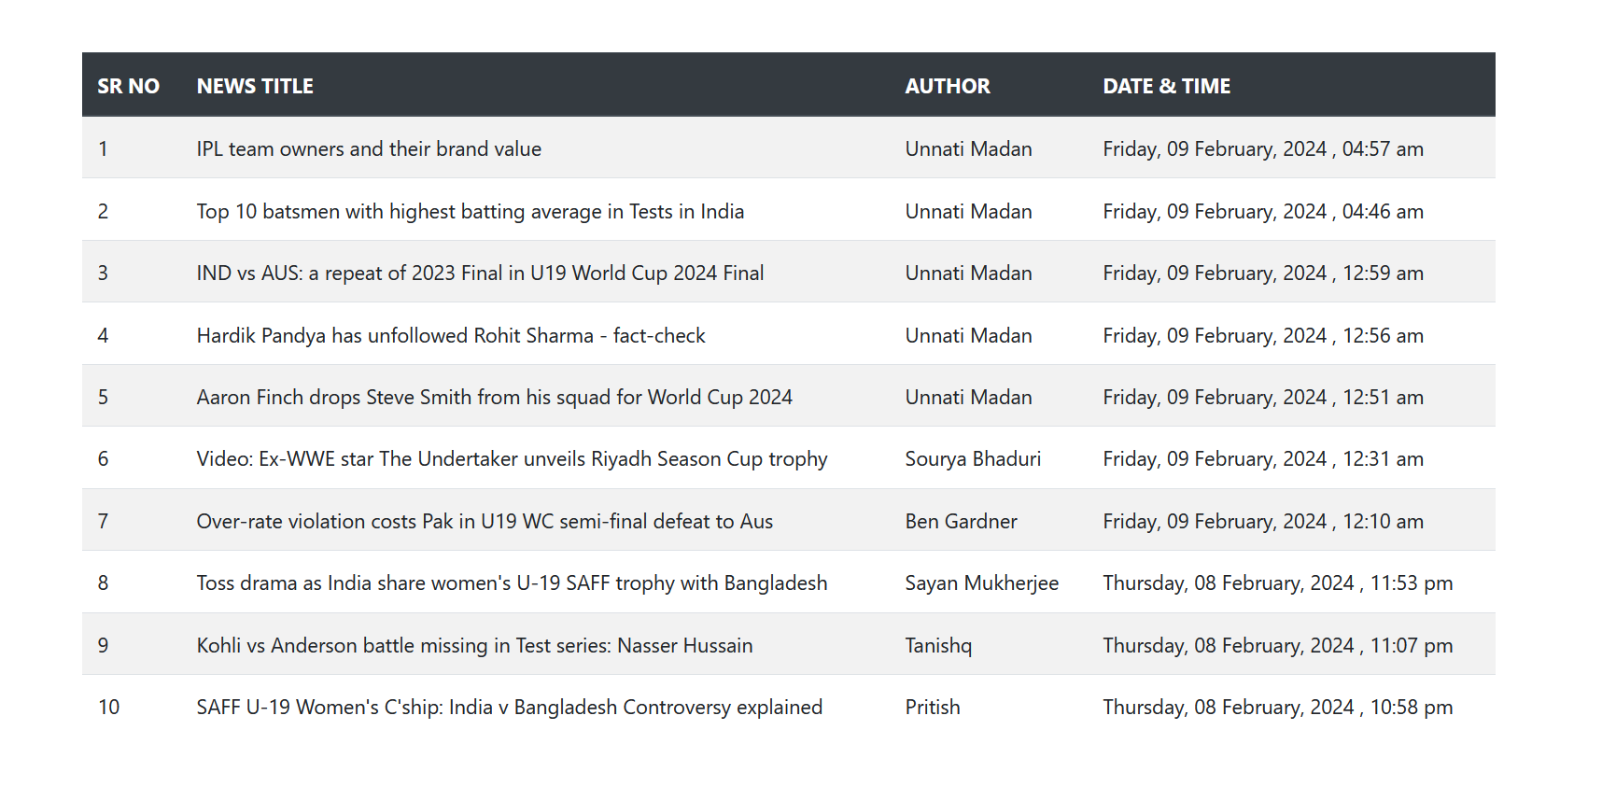

**NOTE :**

1. COMPLETE ABOVE TASK WITHOUT REACT
2. ADD BOOTSTRAP AS SHOWN IN ABOVE SCREEN SHOT.
3. INSHORT API : ONE OF THE MOST WIDELY USED INDIAN SHORT NEWS APP.

**TASK 3 : COMBINATION OF TASK 1 AND TASK 3**

API : <https://inshorts.vercel.app/news/top>

LOAD API DATA FROM NEWS API IN ABOVE CREATED BOOTSTRAP CARDS

[ DIFFICULT ]

